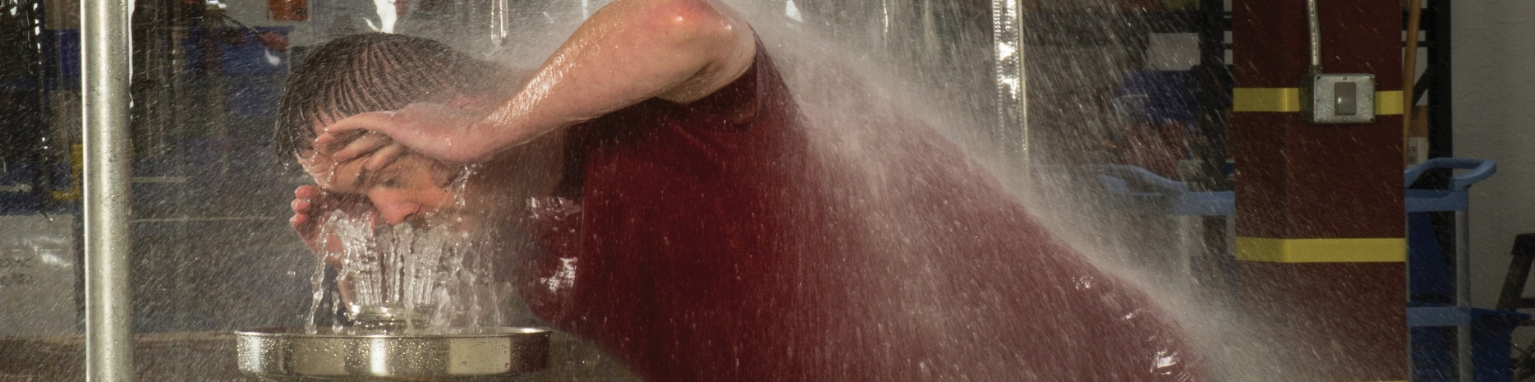
The Hidden Risk In Emergency
Response

Thursday, July 19, 2018
Registration/Networking: 5:30 p.m.
Dinner: 6:00 p.m.
Presentation follows dinner
Harry’s Steak House - 5664 Brecksville Rd, Cleveland, OH 44131 - (216) 524-5300
WHY SHOULD YOU ATTEND?

• To Learn About Real World Research and Insights to Non-Compliance of Safety Shower Standards (ANSI Z358.1)
PRESENTER: Nichole Whisman
Haws Integrated Sales Engineer

Nichole has her Masters Degree in Mechanical Engineering and more than 15 years of engineering experience. Nichole has significant knowledge of fluid process equipment for industrial facilities, and is well versed on the current ANSI Z358.1 Standard and system design. She specializes in identifying cost effective solutions for emergency shower and eye/face wash stations.

• To Learn How You Can Achieve ANSI Z358.1 Compliance

• To Learn How to Specify the Proper Equipment

• To Learn About Tepid Water System Design

WHO SHOULD ATTEND?

• Facility Engineers • Health and Safety Personnel • Project Managers

• Mechanical Engineers • Piping Engineers • Design Engineers

Dinner and registration:
members - $29.00; non-members - $31.00;
ASSE Student and Emeritus Members - $15
Use the attached registration form
or use your credit card via PayPal at http://nohio.asse.org/events/ ==================================================================================================
Registration form – Northern Ohio ASSP – Harry’s – July 19, 2018
Make checks payable to “Northern Ohio ASSP”
Mail with payment to Pat McCon, Northern Ohio ASSP, PO Box 267, Mantua OH 44255-0267

NAME_______________________________________________________________________________________________________________

PHONE__________________________________ E-MAIL______________________________________________________________________

ADDRESS_____________________________________________________________________________________________________________

CITY, STATE, ZIP__________________________________________________________________________________________________________________

MEMBER_____ STUDENT MEMBER______ EMERITUS MEMBER______ non-member_____

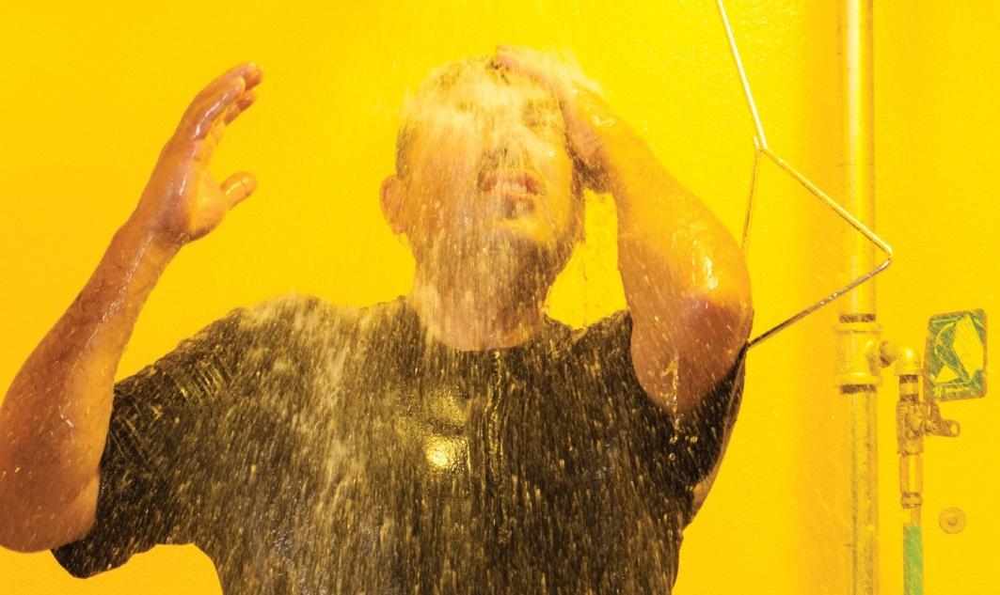
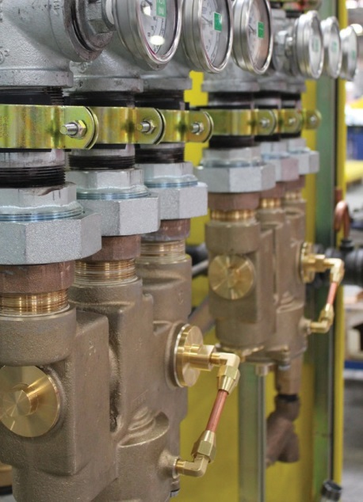
PRESENTATION

OUTLINE

1. Safety Shower Research Findings

2. ANSI Z358.1-2014 Significant Requirements

3. Top Reasons for Non-compliance

4. How can you achieve compliance?

5. Ways to Temper Water

• Point-of-Use

• Centralized Systems

• Standard Designs

6. Piping Design Considerations

7. Installation Recommendations for System Compliance

