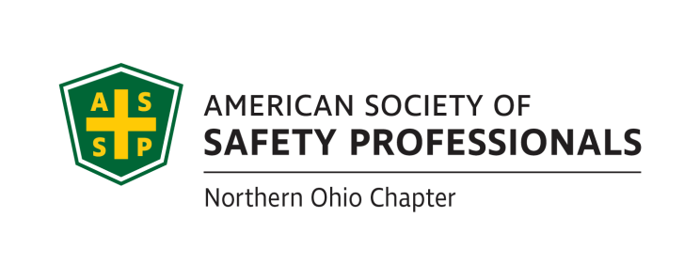
CHAPTER MEETING NOTICE


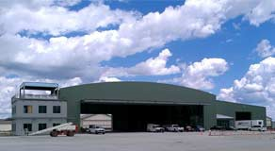
Date: Tuesday, March 19, 2019

Location: Liberty Air Museum, Port Clinton Airport (see over)
3515 E. State Road, Port Clinton, Ohio 43452

Time: Registration and networking – 5:30 p.m.
Dinner – 6:00 p.m.
Presentation following dinner

Speaker - Michael Berakis, Director, Health and Safety, Materion Corporation
“Safeguarding Is Not the Enemy of Productivity”

Cost: $21 members; $23 non-members; $10.50 Student and Emeritus members

The pushback we get when recommending additional machine safeguards is often directed toward the notion that guarding = reduced productivity. Yet experience proves that properly guarded equipment can actually be more productive, not less. Mike will lead the discussion on this topic, sharing some of Materion’s experience in improving machine safeguards.

Register today! Use the attached registration form or use your credit card via PayPal at http://nohio.asse.org/meetings.php. For additional info: pat.mccon@zurichna.com.
==================================================================================================
Registration form – Northern Ohio ASSE – March 2019 meeting at Liberty Air Museum
Make checks payable to “Northern Ohio ASSP”
Mail with payment to Pat McCon, Northern Ohio ASSE, PO Box 267, Mantua OH 44255-0267. info: pat.mccon@zurichna.com

NAME PHONE E-MAIL

EMPLOYER

ADDRESS

CITY, STATE, ZIP

About Liberty Aviation Museum - http://www.libertyaviationmuseum.org

The Liberty Aviation Museum was established on December 7th 1991 with a handful of dedicated volunteers to showcase WW2 aircraft. In 1994 we had the opportunity to put on a well received air show at the Erie-Ottawa Regional Airport in Port Clinton, Ohio. This very fortunate turn of events led us to formally announce in 1996 our intent to locate our museum at the Erie-Ottawa Regional Airport.

Embracing the deep aviation heritage of the area we began to plan for a facility to include a hangar and museum along with a 1950's era themed Diner.

In 1994 we undertook a search to locate and return to the airport a flyable Ford Tri-motor, and in October of 1996 we were fortunate indeed to come into contact with Maurice Hovious - a world renowned Ford Tri-motor expert and restorer.

This initial contact later inspired Maurice Hovious to further his dialogue with Ken Benjamin who convinced Maurice to make this unique idea a reality. Since then an amazing amount of work has been completed by EAA Tin Goose Chapter 1247 volunteers on the restoration of a new Ford Tri-motor project sponsored by Maurice. This progress then led to the Establishment of the Tri-motor Heritage Foundation - taking up the torch to be the caretaker of this rare treasure.
In 2010 we acquired flyable vintage WW2 North American B-25 Mitchell Bomber. The 2011 season was spent training crews to fly her at air shows throughout the year. Our B-25 underwent comprehensive restoration work at Aero Trader in Chino, California over the winter of 2011/2012.

In 2011, the dreams of all three organizations to have a permanent place to call home became reality with the announcement that a Museum/Hangar facility would be built at the Erie-Ottawa County Regional Airport. The museum facilities opened to the public in July, 2012, and was heralded by the arrival of the newly refurbished B-25, "Georgie's Gal."

About the area

It’s no accident that we scheduled this meeting for a Friday afternoon just after Labor Day. We’re hoping that you’ll bring your family along and make it a recreation weekend! There’s a lot to do in the Shores and Islands region, starting with the Liberty Aviation Museum. And it’s a much more relaxed atmosphere after Labor Day!

Other attractions include: CEDAR POINT
THE ISLANDS – ENTERTAINMENT, HISTORY, GEOLOGY, PARKS South Bass Island (Put-In-Bay)
Middle Bass Island
Kelley’s Island
Johnson’s Island (Confederate POW Cemetery) INDOOR WATERPARKS
AFRICAN SAFARI WILDLIFE PARK
PERCH AND WALLEYE FISHING CHARTERS MARBLEHEAD LIGHTHOUSE
WINERIES
EDISON’S BIRTHPLACE

And lots more – see the regional web site at http://www.shoresandislands.com/itinerary/Ohio-Attractions.

Hope to see you there!

